Circle Language Spec: Interfaces

Interface Aspect in System Interface
System aspects can be shown in the system interface notation as worked out in the System Interfaces articles in the System Objects chapter. The Interface aspect was not covered there, so this is a supplement to that documentation.

Object-Interface in System Interface
The Interface aspect has five system commands, but only two of them apply to Objects. The other ones apply to references. The Interface aspect of an Object is controlled through the following commands:

Use As Interface
Object-Interface Get

The commands are placed inside the system interface inside a triangle that wraps together the members of the Interface aspect:

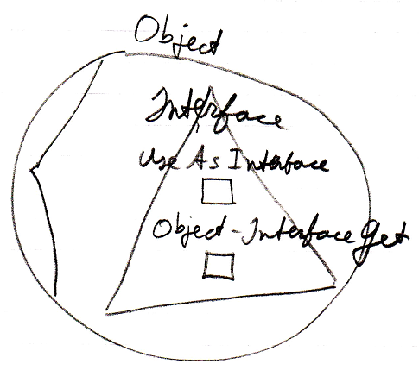

Reference-Interface in System Interface
The Interface aspect has five system commands, but only three of them apply to Related Items:

Interface Set
Reference-Interface Get
Use Reference As Interface

The commands are placed inside a triangle, that wraps together the members of the Interface aspect:

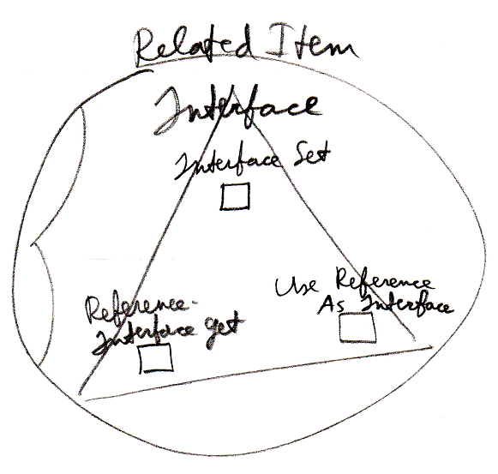

It works the same for a Related List Item as it does for a Related Item.

Reference-Interface in System Interface of Related List
A list can centrally control the aspects of its items. Therefore, a list can control the Interface aspect of its items, centrally setting the Interface that all the items must support.

The system commands to do this are placed inside a triangle that wraps together the members to control the Interface aspect:

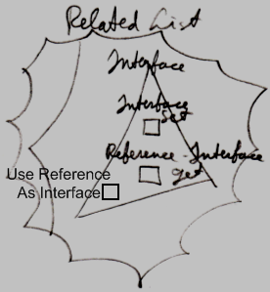

Interface Merging in System Interface
The Interface Merging aspect only applies to Related Items. It is controlled through two commands:

Interface Merged Get
Interface Merged Set

The commands are placed inside the system interface inside a triangle, that wraps together the members of the Interface Merging aspect:

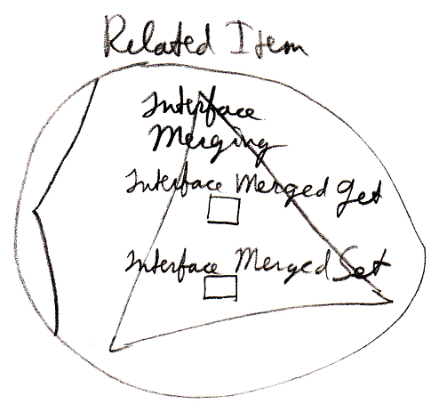

Interface Merging does not apply to Related List Items, because it does not seem to be practical there.

